**Unit 73**

Communication Skills for Creative Media Industries

*Assignment 1 – Sound and Music in Games*



Content

# Noise Art: The Use of Sound and Music in Games

## Description of the use of sound in games

## Description of the use of music in games

## Sound and File Formats

# Sound Types and File Formats

## Foley Artistry

## Sound Libraries

## Sound Formats

## Mono Audio

## Stereo Audio

## Software Sequences

## Software Plug-ins

## MIDI

## MIDI Keyboard Instruments

## Sound Compression

## Sound Decompression

## Uncompressed

## Lossless Compression

## Sound Processor Unit (SPU)

## Digital Sound Processor (DSP)

## Random Access Memory (RAM)

## Surround Sound

## Direct Audio (Pulse Code Modulation – PCM)

## 3D VR sound

## Digital & Analog

## Digital Mini Disc

## Compact Disc (CD)

## Digital Audio Tape (DAT)

# Legal issues

## Copyright & Fair Use

## Licences

## Ancillary rights

## Royalties

## Property rights

## Talent release contract

# Theory of sound

## Describe Sound

## Property, moving object,

## What is a square wave?

## What is an audio spectrum?

## Describe complex sounds

## Describe sound wave

## Describe wave form diagram

## Describe a pitch (Hz)

## Describe frequency

# Noise Art: The Use of Sound and Music in Games

## Description of the use of sound in games

Sound in games are as important as the visuals of a game it is a necessary feature you must have to enjoy a game to its full potential. Sound in games is a necessary feature as it immerses the player into the movement, action and storytelling of a game by bringing it to life. Sound can convey a character’s emotions which makes it easier to understand what is happening and amplifies it giving the player a more enjoyable experience.

## Description of the use of music in games

Music in video games allow the player to truly be captivated as it sets the mood, the themes and emotions of a game. Having music in games brings the storytelling as it gives emotion and depth to the characters.

## Sound and File Formats

It is important to know the file format of a sound track or a music track as some game engines will have compatibility issues which means the soundtracks we will import will not play on the game we have developed.

### Wav File Format

Wav file format is the format that is used regularly on pc’s especially on nearly all windows applications that support sounds. It is the format for audio files. It is supposedly better quality than MP3. It is mainly used for music CD’s and has gone widespread and is now a standard PC audio format. It is good as it is an easily accessible format as it can be played by nearly all window devices. Also, it is fast at decoding meaning it can read and play files quickly. However, WAV files are very large as it keeps all the data of the file such as how many tracks are on the file, whether its mono or stereo, the sample rate of the file, the bit depth and the uncompressed raw audio data. Construct 2 only accepts .wav files.

[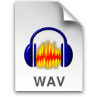](https://en.wikipedia.org/wiki/WAV)

### MP3 File Format

MP3 is an audio file format used mostly for storing songs onto devices with little storage as MP3 files are 11 times smaller than uncompressed music tracks, usually from 50 MB to 4MB. The reason the file sizes are so small is because it strips down the sounds we can't hear from the file. Which makes it so that you can fit 100 songs onto a CD using MP3 whereas you can only fit 16 songs onto a CD using the WAV file format that’s an 84-song difference just, so you can hear 14 sounds that usually sound like white noise. However, many creators stay away from MP3 as it's easy to pirate MP3 files meaning creators could be stolen from.

[](https://en.wikipedia.org/wiki/MP3)

### .aiff

AIFF is an acronym for Audio Interchange File Format, this file format was initially created by Apple Computer for storing and uploading high quality audio data. AIFF supports a selection of bit resolutions, sample rates and different channels of audio. This format is widely used by Apple devices and is also sometimes used in professional programs to handle digital audio waveforms.

AIFF files are uncompressed meaning that they are large compared to the small MP3 files. AIFF files are similar to WAV files as they are both large in size, high quality and perfect for burning onto CD's.

[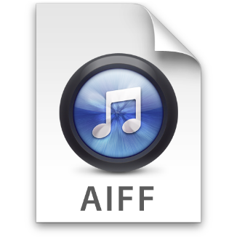](http://www.iorgsoft.com/glossary/aiff.html)

### .au

AU is short for audio this is a common format for sound files on UNIX machines (a family of multitasking, multiuser computer operating systems) the AU file format was first used by Sun Microsystems (the company that made the Java programming language). The AU file format is a standard for the Java programming language.

[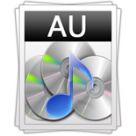](http://www.open-bluray-ripper.com/formats/au.html)

#### .smp

.smp stands for Sample Vision File Format it was developed to be used with the Sample Vision software program, it was designed to send and receive audio samples using the MIDI interface on a computer. It consists of a variable-length header followed by a contiguous block of binary data representing the sound samples.

[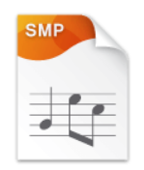](https://fileinfo.com/extension/smp)

# Sound Types and File Formats

## Foley Artistry

### What it is?

Foley Artistry is the method of reproducing everyday sound effects so that it can be added to films, television shows, games and other types of media in post-production to make the movie more realistic as it is hard to capture background audio such as a tyre skid on set as the microphones are under clothing on the person’s chest to record their voice, so they use a hot water bottle instead and scrape it across a table.

[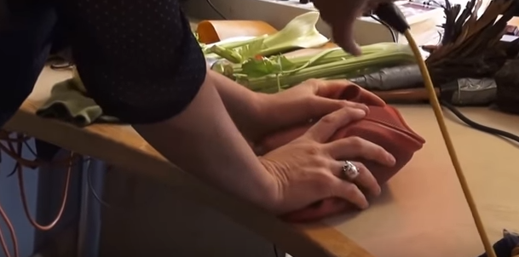](https://www.youtube.com/watch?v=GrbgY6ajTgo)

### Where it is used?

Foley Artistry is used in all types of media production as mentioned in the “What it is?” paragraph. The sounds ae produced in a high-end studio with expensive and very sensitive microphones to capture the audio as crystal clear as it can be.

### Why it is used?

Foley Artistry is used because some sounds are hard to capture into suitable audio to be used in production. Secondly, if someone is meant to have their bones broken in a game you can’t break some bones and capture that as audio, so they break celery instead. Thirdly, the sound of a punch on skin sounds like a slap so instead every punch sound effect in a game is the sound effect of someone punching a sandbag instead to get that shocking thud sound.

### History

[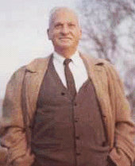](http://filmsound.org/foley/jackfoley.htm)Foley was originally developed to be used for live radio broadcasts in the early 1920’s in certain radio studios around the globe. Foley was used as the recording software was not good enough to record and replay sounds on live radio broadcasts, so they had to hire people specifically for creating sounds live on radio. The first person to do this was named Jack Donovan Foley hence the name. Jack Foley was hired by Universal Studios in 1914 when silent movies were popular. When the first movie to include sound was being made, The Jazz Singer, they came across a problem and that was that the microphones back then could only pick up the dialogue/speech of the movie so when watching the movie, it didn’t sound normal like a movie should sound. To fix this they asked for any employees with background knowledge in radio and there came Foley and a couple of others. What the team did is they projected the movie onto a screen and recorded the audio on a single track for the whole movie at the same time precisely making it, so they recreated each footstep perfectly and other things so that the sound other than the dialogue synchronised perfectly with the film. Jack Foley worked in audio for films until his death in 1967.

Nowadays with the recent technological advances audio does not have to be recorded live on one track. Different sounds can be recorded separately and carefully synchronised with the film. Foley studios employ hundreds of props and digital effects to recreate the ambient sounds of their films.

## Sound Libraries

A sound library is basically a folder filled with audio files which contain certain sounds such as the sound of rain, so you could loop that track and constantly keep playing it in a game. They are often used when developers don’t have the time to create the audio files themselves as sound libraries are usually cheap or inexpensive way of obtaining sound files to be used in games. Although while buying sound libraries is convenient and are decent quality they could just not contain the specific sound the developer is looking for.

[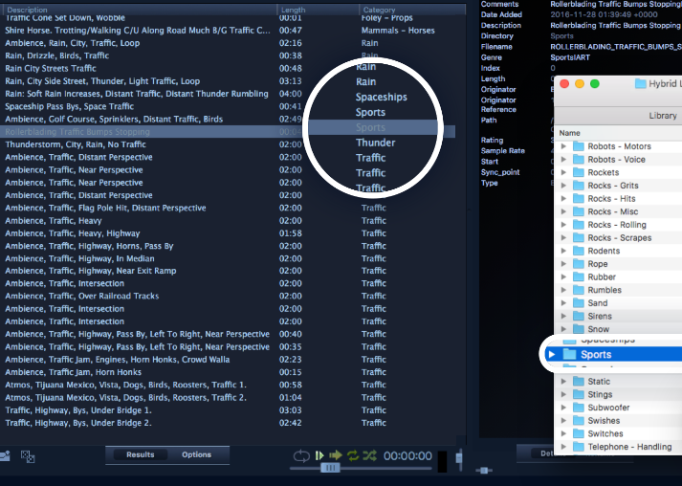](https://www.prosoundeffects.com/)

## Mono Audio

Mono audio is audio that is produced using one mic so there is only one audio signal so if you were to play it through 2 speakers both speakers would output the same sound.

Someone would use mono audio as the equipment to produce or listen to is inexpensive and less complex to make. Secondly, it produces much smaller file sizes compared other forms of audio such as stereo approximately by half.

Mono audio is mostly used in radio talk shows and telephone calls so no matter where you are such as positioned in a room you will all hear the same audio as everyone else. Secondly as with these situations you don't need to know the direction of where the audio is coming from. Finally, as it is cheaper and less complex meaning you can make the equipment small such as to fit in a phone while also making the product a reasonable price.

One of the only problems with mono audio is its defying flaw and that is its inability to give the user a sense of direction of where the audio is coming from as the sound it produces has no element of direction plus location.

[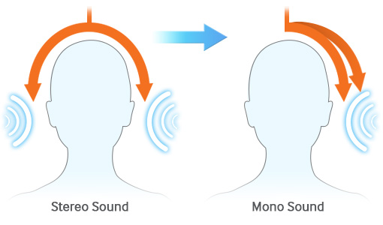](http://www.samsung.com/uk/mobileaccessibility/)

## Stereo Audio

Stereo audio is audio that is produced using 2 or more mics so there are multiple audio signals making it so that stereo sound shows the user then direction and location of the audio such as is the sound coming from the left or right.

The major cons of using stereo sound is that it is more expensive to set up than mono audio but to be honest it is very cheap to get the equipment for it. Also, as it produces larger file sizes but the increase in technological advances have made it so that space is not really an issue now.

The positive of using stereo audio is that it provides sound direction and location which provides a better experience in sound and realism especially when playing a game as you will be able to tell for example where gunfire is shot making a game more enjoyable.

## Software Sequence

This is a software that allows you to play, edit or record music. They even incorporate sound libraries. A popular software sequencer is audacity.

[](http://www.audacityteam.org/)[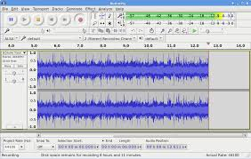](http://www.audacityteam.org/about/screenshots/)

## Software plug-ins

Software plug-ins are small computer applications that run inside the main application usually a sequencer. A good example of a software pug-in is the very popular adblocker what this does like the title is run in the background and stops nasty popups from appearing on your screen while browsing the web.

[](https://getadblock.com/)

Although plug-ins may seem useful, if you download a faulty plug-in, which are usually the free ones, it can cause stability problems with the sequencer. As the developers usually release the plug-ins with bugs and then will fix them when customers start complaining also when a new operating system is released that usually causes plug-ins to stop working.

## MIDI Keyboard Instruments

MIDI stands for Musical Instrument Digital Interface, and is an industry-standard protocol that's been around for a sum of 25 years, a MIDI instrument is usually a piano-style user interface which is used for sending MIDI signals/commands via a USB or MIDI cable to a computer usually running a software sequencer that takes the inputs from the MIDI instrument and reproduces the array of digital sounds or samples that resemble the traditional analogue instrument by using a sound library of what each note of the instrument should sound like. There can be MIDI instruments other than the piano such as an electrical drum kit of even pads with buttons on it that send MIDI signals to the computer.

MIDI instruments are used as it transfers the input information directly to the computer making it easier to create music as you don’t have to get a microphone and record hoping that it sounds good as you can’t edit it whereas with a MIDI instrument you can edit everything on the computer so if you make a mistake when recording if doesn’t matter because you can fix it and even make it sound better by increasing and decreasing the volume of certain parts of the piece.

[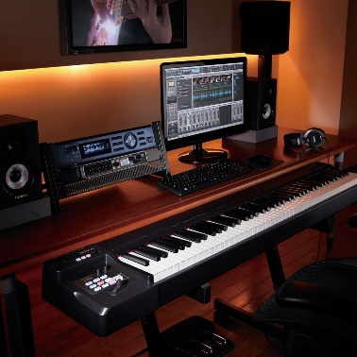](https://www.dawsons.co.uk/roland-a-88-usb-midi-keyboard-controller) [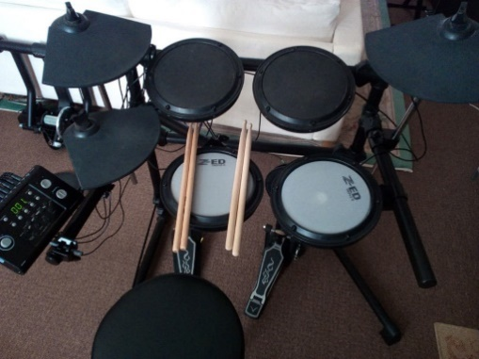](https://www.gumtree.com/p/drums/electronic-drum-kit-with-2-mesh-heads-mapex-stool-and-sticks.-midi-connection./1236354095)

## Sound Compression

Compresses sound files to make them smaller in size it does this by getting the wavelength? And placings rectangles underneath it the less bit depth? The bigger the rectangles underneath.

Digital sound files can be compresses or uncompressed. Compressed sound files have smaller file sizes, so it can be more easily stored on a game disc or downloaded off the internet faster. However, there is a downfall in compressing sound files as if you use lossy compression bits of the file could go missing such as repeated beats or sounds in a track/song although it will decrease the file size drastically. Whereas if you use lossless compression the file size won’t be as small as a lossy file, but it will not delete anything, but the quality of the file will decrease.

The way you compress a sound file is by using an audio compressor software which you can get on a computer this will then even out the volume level of an audio track this makes it, so you can hear the loud and soft parts of a song. This is done by going on an audio track in the compressor software and setting the threshold on the sound wave to what you want it to be at anything above the threshold will be compressed and anything below uncompressed.

[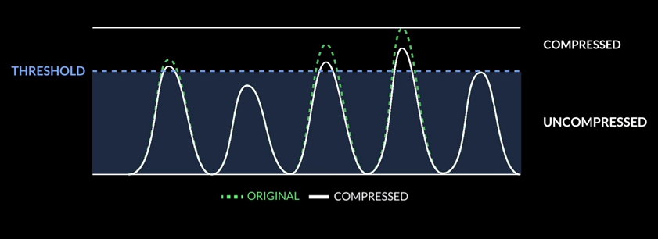](https://www.youtube.com/watch?v=IbIC7B4BU6g)

## Sound Decompression

To use a compressed file such as an audio file you first must decompress it which means that when you compress a file a lower its file size and save it onto a computer when you go to reopen the compressed file your computer automatically decompresses it, so it will be able to play the song. However, each file extension need a specific software which your computer usually must decompress it such as a .zip file needs the WinZip software to decompress it.

## Uncompressed

An uncompressed sound file is a raw audio file that has not been compressed meaning it has a very large file size and this is because nothing has been removed from it this makes it, so the sound file is high quality as it is the best quality it can be.

## Lossless Compression

This allows you to compress a file and keep everything, all the data that is on that file so if you save a music track with lossless compression when you open it up and play it, nothing will be missing, and the song will have everything in it. Whereas if you were to save a music track using lossy compression and then replay it usually wouldn't sound the same as there would be a loss of audio quality. It manages to do this by eliminating redundant information or shortening information such as if in picture multiple pixels are the same colour it will code it so there are 45 blue pixels instead of saying “blue pixel, blue pixel, …”.

## Sound Processor Unit (SPU)

A SPU also known as a sound card is internal hardware which provides the input and output of audio signals. Most SPU’s use a digital to analogue converter, this turns audio data into an analogue output. Then the analogue out is ready to be played through a speaker to produce sound for the user to listen too. Depending on if you have a cheap or high-end model of a sound card can alter the limitation of the sound quality of the user’s machine. Sound cards consist of small sound chips that are installed onto the cards they are responsible for the audio quality of the card, so expensive and high-quality SPU’s contain more sound chips. A better-quality sound card allows the user to enjoy and experience a game to its full potential with the inclusion of surround sound which is achieved by having multiple speakers placed around a 3D space. For example, when playing the game Counter Strike: Global Offensive with surround sound it is amazing as you can hear where every single gunshot is coming from giving the game a totally different experience when compared with not using surround sound as you must guess where gunfire is being shot causing the game to become frustrating and not entertaining the opposite of the games intent.

[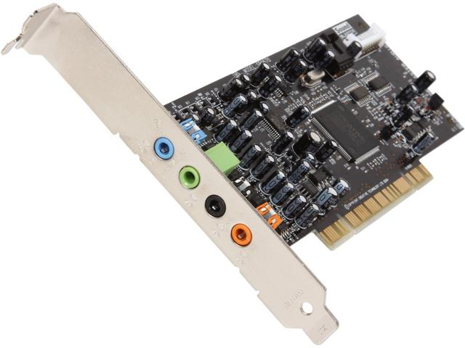](https://www.newegg.com/Product/Product.aspx?Item=N82E16829102003)

## Digital Sound Processor (DSP)

Digital sound processors basically turn real life sounds such as your voice and turn them into digital sound waves this is done by using mathematical algorithms in real time which are functioned on a computer or even a smart phone.

## Random Access Memory (RAM)

RAM is a type of memory which is fast acting and temporary. RAM is used by programs, application and data which is then stored. Some examples of what is stored in RAM are the operating system, applications and the graphical user interface (GUI). When the computer is turned off all RAM data is deleted to be used again when the computer is switched on. If the computer does not have enough RAM for programs they will become unstable, laggy, will start to crash and in some cases not even work at all. Audio in games can also be affected by RAM as if there is not enough to support the sound it will decrease in quality, this is because the system struggles to equally spread the RAM out to keep other applications running as well as the game. His consequently could mean the audio for the game will become distorted and skip beats.

[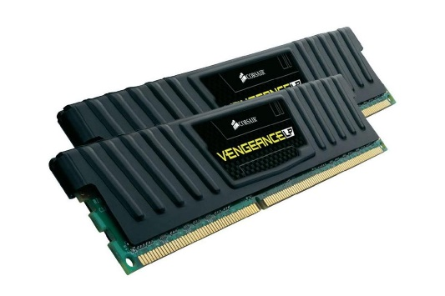](https://www.lifewire.com/what-is-random-access-memory-ram-2618159)

## Surround Sound

Surround sound is when you have multiple speakers surrounding you although you only need two such as a set of headphones. Surround sound makes it so the user has a sense of sound direction this is needed in video games such as Counterstrike: Global Offensive so you are able to tell where you are getting shot from without this the player would easily die repeatedly and get frustrated with the game making his experience of the game less enjoyable.

[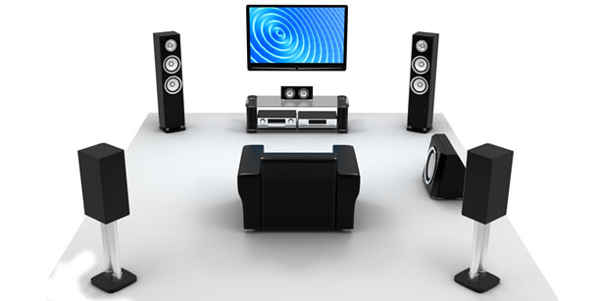](https://www.the-home-cinema-guide.com/surround-sound-speakers.html)

## Direct Audio (Pulse Code Modulation – PCM)

Pulse code modulation is a method used to convert analogue audio (real life audio) to digital audio. This method includes three steps: sampling, quantization and coding.

In the sampling process the magnitude of the analogue signal is sampled regularly at each interval of the sound wave. Next is the quantization process, in this process each sample created in the sampling phase is turned into digital data. Then in the final step a coding algorithm is used to transform the data into digital sound waves, this algorithm is complex and is too difficult to explain.

## 3D VR sound

3D VR sound is like surround sound except heavily improved as before with surround sound you had an idea of where a shot was fired but you had to guess where the enemy was based off that whereas with 3D VR sound you will be able to pin point where the shot was fired. This is achieved from sculpting a human head and putting microphones where the ears are so the microphones pick up sound exactly as we do in the real world.

[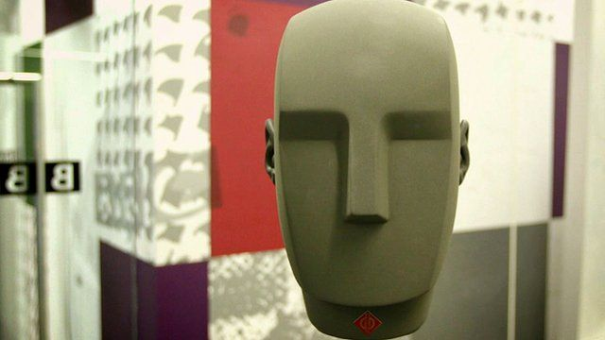](http://www.bbc.co.uk/news/av/technology-36138003/how-this-head-is-helping-give-you-3d-vr-sound)

## Digital & Analog

Digital sounds are a series of pulses containing the binary states on (1) and off (0). They are transmitted as digital signals.

[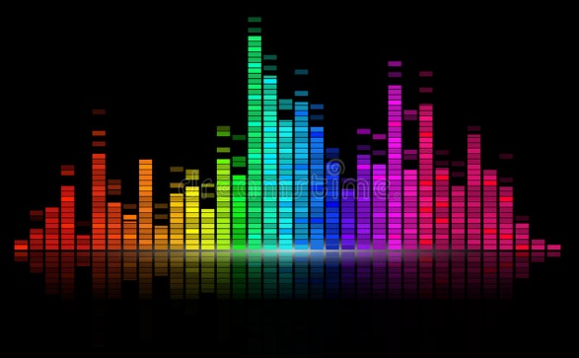](https://www.dreamstime.com/royalty-free-stock-photos-digital-sound-equalize-image17525248)

Analog are non-digital forms of sound such as speech and music from a guitar in real life. Analogue supposedly sounds better than digital, but they virtually sound the same and you can only notice the difference when you listen to them both in a professional studio.

[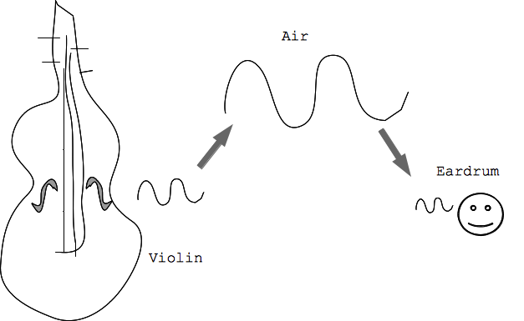](https://web.stanford.edu/class/cs101/analog-digital-1.html)

## Digital Mini Disc

## A digital mini disc also known as a minidisc recorder is used to compress audio when it is being transferred onto a CD. This compression causes the audio on the CD to lose quality however it also makes the file size of the audio much smaller. Finally, because the audio is burnt to the CD it means it is hard to edit the file therefore they are not used regularly in a professional environment such as when making a game as you don’t want music or sound effects that you can’t edit.

## Compact Disc (CD)

## Compact disc’s or more commonly known as CD’s can contain high quality audio as they use Wav files. However, CD’s are hard to edit meaning when writing to a CD you can’t make any mistakes. CD’s aren’t that robust as even one small scratch could ruin a whole CD making it unplayable. CD’s are used quite a lot but not so much now in the gaming industry as it is cheaper for game developers to put there game on the internet to be sold rather than on a CD as they are costly but none the less they are still used by bigger companies such as EA as their target market for their games prefer having games on a disc as it adds an extra bit of security as if you download a game then the computer or console gets damaged or breaks the game file could be deleted and lost forever.

[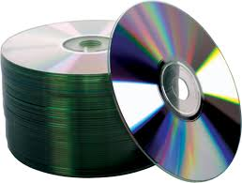](http://www.mediatekoptical.com/2015/09/08/cdmediabasics/)

## Digital Audio Tape (DAT)

Digital audio tape or DAT for short consists of analogue data turned into magnetic energy which is then stored on tape. DAT was used back in insert date but us no longer needed now in the professional industry such as the gaming industry as digital audio tape is very tedious to edit as you must cut strips out of the tape then stick the two ends back together and well there are plenty more ways which are convenient to the user to edit audio. Also, the magnetic data stored on the tape degrades after so many years causing data to be lost which would be horrible if game developers used this as you would get the game and after so many years it could be useless and unplayable.

[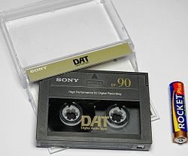](https://en.wikipedia.org/wiki/Digital_Audio_Tape)

# Legal Issues

## Copyright & Fair Use

If a piece of audio is copyrighted by the creator this means the piece of audio is protected under certain rights. This allows the creator to sue someone who uses their piece of audio without permission or if it is used unfairly. Fair use is when a piece of audio is used correctly under the copyright laws, for the use of a track to be fair it must have a good intention, not use too much of the song/track and finally to not represent the song/track in a bad manner. Also, you can purchase copyrighted music for example and have the ability to use it for a limited time before the contract expires. A copyright can last for the life of the creator plus 70 years, a creator can sign a copyright share to a publisher for a stream of income, 35 years after the share you can take the copyright back. Many years ago, creators used to put their song or lyrics in an envelope and send it to themselves and keep the receipt and never opened it until someone copied their music then they would sue the person who copied and show the receipt and envelope to the judge and then they would win the court case, this is still valid today. Creators did this as it used to be very expensive to copyright something and lawyers/solicitors were too. Also copyrighted things such as pictures usually have the copyright symbol on it, but the copyright symbol does not actually have to be there to be copyrighted.

[](https://www.thespruce.com/copyright-symbol-on-windows-and-mac-2688246)

## Licenses

When licensing an audio product such as a song you have to say what it will be used for and where it will be used, this is the term and the territory, then if the creator of the song agrees you then buy that license and then you are free to use the song for that specific purpose. For example, if a game developer wants a specific song for a cut scene they will get a license, so they are able to play the song only on that cutscene. However, if the game developer then uses the song in another game or cutscene they could be sued by the creator of the song as they didn’t have the specific license to play it on that game or different cutscene.

## Ancillary Rights

When a game is produced and sold on Steam or Xbox they will get a percentage of the profit made off the game so will the insurance company, packaging, postage and CD cost. Ancillary rights give creators a percentage of the profit made of products that were created after the initial product was made. For the composers who created the music of a game this could mean it can be used in a sequel or even the games soundtrack released as a CD and the composer would still earn a percentage of the profit made off these products. An example of this is with the franchise of Sonic as after the game was released there was a TV show made after the beloved hedgehog meaning if they used the same sound effects in the TV show from the game the creator of those sound effects will get a percentage of the profit made off the TV show.

## Royalties

Royalties are multiple payments given to the creator/owner of an audio file over a set period. However, most royalties in the gaming industry for soundtracks are paid in one single fee to the composer for the license of the music. Although in the gaming industry royalties are usually paid with one payment they are meant to be a certain percentage of the game’s overall profits which is established with the creator of the game.

## Property Rights

Property rights also known as intellectual property is the property of one’s own mind. They protect a developer’s creations for example, characters, lyrics, music and software then make it so they people cannot steal their creation and claim it as their own. This makes it so if a game company buys a soundtrack for their game they cannot say they made it and redistribute it as their own.

## Talent Release Contract

These are contracts that grant game developers permission to officially use a piece of sound in a game. Usually talent release contracts make it, so composers of the soundtrack can’t change their music or idea after the contract is signed and that they can’t ruin any part of the game or sue, as the developers are using the soundtrack under fair use. A talent release contract is good for both parties as the developers must use the piece of music fairly under the assigned agreement and the composers can’t change their mind after signing the contract.

# Theory of Sound

## Describe Sound

Sounds are made up of waves, waveforms are the representation of how sound is transferred in to waves by the ear. There are many different types of waves such as: sine waves and square waves.

Sine Wave:

A sine wave is a single harmonic vibrating at a predictable frequency which has a smooth repetitive oscillation. An audible sound wave can only be created by an electrical oscillator.

[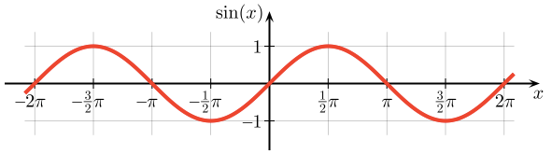](https://betterexplained.com/articles/intuitive-understanding-of-sine-waves/)

Square Wave:

The square wave compared to the sine wave contains strange harmonics and sound a lot more electronic, also the square wave is symmetrical.

[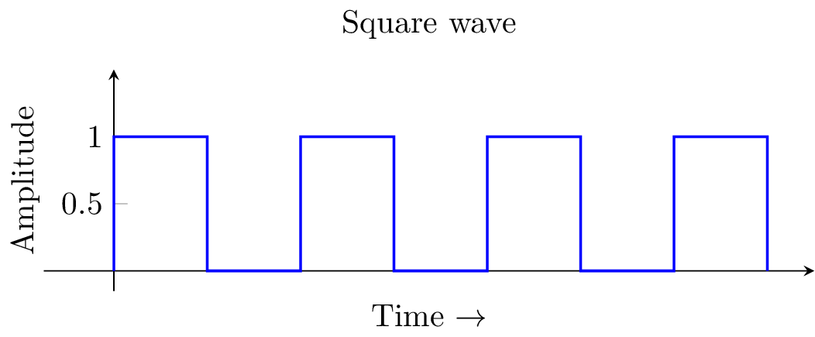](https://tex.stackexchange.com/questions/113046/how-to-draw-a-square-wave)

## What is an audio spectrum?

The audio spectrum is the range of frequency at which human beings can hear sound. This spectrum ranges from **20 Hz to 20,000 Hz and has seven different categories each changing the way we hear a sound.**

**Firstly, there is the Sub Bass frequency band which can range from 20 to 60 Hz, the sound produced at this frequency is not really heard but felt. An example of this is when you are at a concert and you can feel the music vibrating in your body.**

[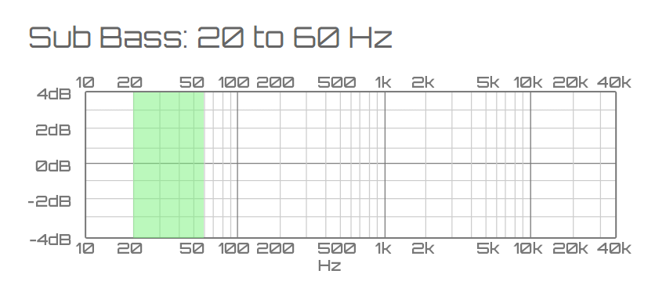](https://www.teachmeaudio.com/mixing/techniques/audio-spectrum/)

**Secondly there is the Bass frequency band which can range from 60 to 250 Hz, depending on how much bass there is (the higher up it is on the spectrum) determines how fat (deep) or thin (high pitch) the sound produced is.**

[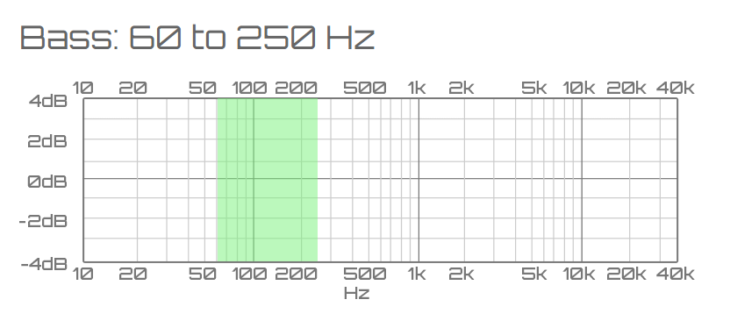](https://www.teachmeaudio.com/mixing/techniques/audio-spectrum/)

**Thirdly there is the low midrange frequency band which can range from 250 to 500 Hz, this adds the harmonics (**high pitch sounds**) to the sound, at around 300 Hz it adds clarity to the bass and if its turned to the 500 Hz range it will instruments sound muffled.**

[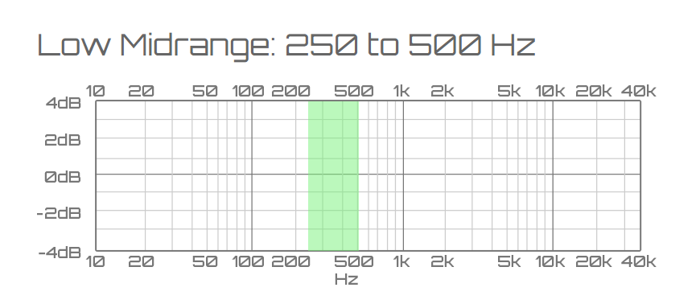](https://www.teachmeaudio.com/mixing/techniques/audio-spectrum/)

**Fourthly there is the midrange frequency band which can range from 500 Hz to 2kHz, this determines how prominent a sound is in a track like drums or a guitar in a song. At around 100 Hz it will make instruments be as prominent as a horn and if the frequency is set to high it will cause instruments to sound tinny and on some occasions, give people ear fatigue.**

[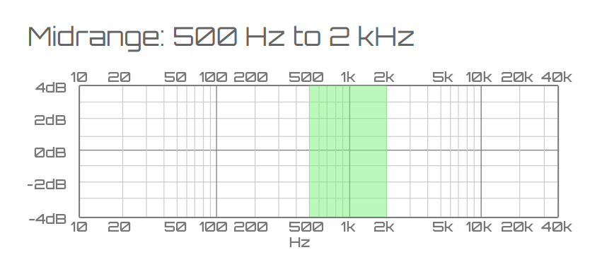](https://www.teachmeaudio.com/mixing/techniques/audio-spectrum/)

Fifthly there is the upper midrange frequency band which can range from 2 to 4kHz, percussion is most prominent at this frequency range and if turned up it can give the percussion sound such as drums more attack and loudness in a song.

[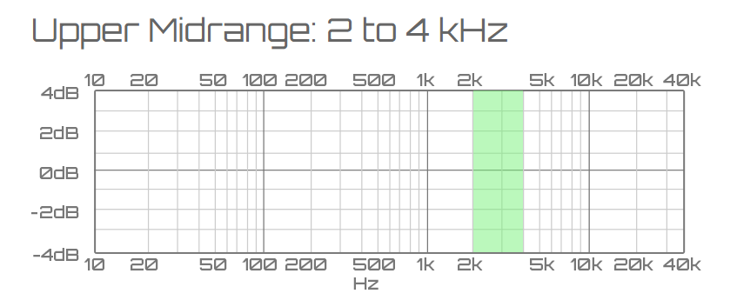](https://www.teachmeaudio.com/mixing/techniques/audio-spectrum/)

Sixthly there is the presence frequency band which can range from 4 to 6kHz, this range is most popular for controlling the treble (high notes) on home stereos.

[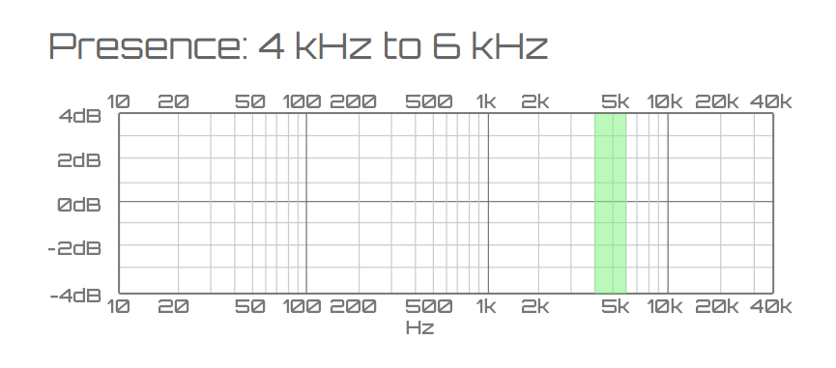](https://www.teachmeaudio.com/mixing/techniques/audio-spectrum/)

Finally, there is the brilliance frequency band which ranges from 6 to 20 kHz, this frequency band only contains harmonic sounds.

[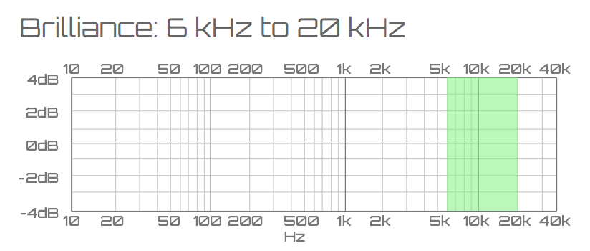](https://www.teachmeaudio.com/mixing/techniques/audio-spectrum/)

## Describe complex sounds

Complex sounds are basically every other sound wave other than a sine wave such as natural sounds like water splashing. Complex sound waves are made from multiple harmonics vibrating at many differing frequencies.

[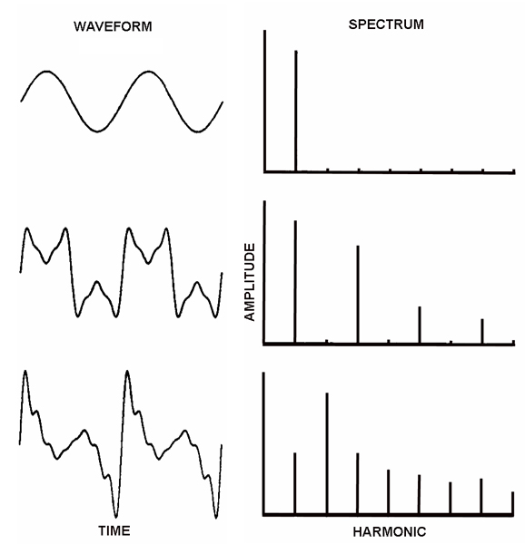](http://www.prosoundweb.com/topics/education/sound_wave_propagation_the_bigger_picture_of_what_we_hear1/)

## Describe sound wave

Sound waves are longitudinal vibrations caused by pressure which is then set in motion by an event that creates energy (vibrations), this could be anything from someone kicking a door to a dog barking as they all generate vibrations that our ears can then convert into sound. The reason we can hear sound is because when a sound wave moves from left to right in the air it creates vibrations in the air molecules which then go into our ears and causes our eardrums to vibrate which our brain interprets as sound.

## Describe wave form diagram

Waveforms are the representation of a sound wave displayed as a graph. Waveform graphs show the amplitude and the wavelength of a sound wave.

[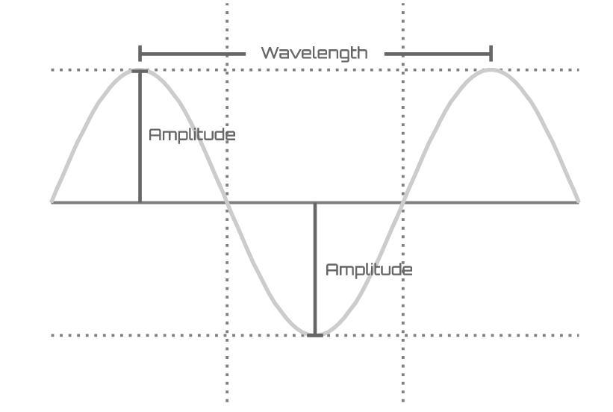](https://www.teachmeaudio.com/recording/sound-reproduction/sound-waves/)

The amplitude is how far the wave goes up and down in a single cycle. The greater the amplitude, the louder the sound.

The wavelength is the length of one full cycle of a sound wave measured in metres. The greater the wavelength the longer and slower the sound.

## Describe frequency/pitch

The frequency is how many complete sound waves there are per second. This basically measures the pressure generated from the sound wave. Frequency is measured in hertz or more commonly seen as Hz. Frequency determines the pitch of a sound wave; lower frequency waves have longer wavelengths and a lower pitch whereas higher frequency waves have shorter wavelengths and a higher pitch. Humans can hear frequency from the range of 20Hz to 20kHz (20,000 Hertz), this however degrades as we get older.

[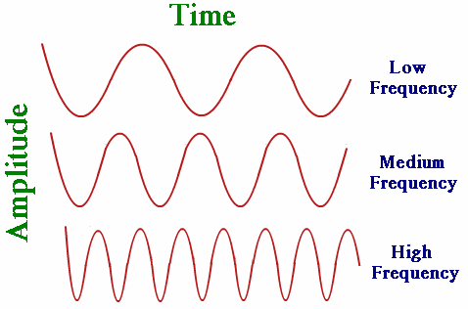](http://physics.tutorvista.com/waves/wave-frequency.html)

# Conclusion

This work allowed me to understand the concept of Foley artistry and that all sounds in a movie are not recorded on set and are added in pre-production using various techniques to represent the sound. Also, that all compressed files are decompressed when opened so the computer can read the file. I have also found out that humans can’t hear above 20 kHz or below 20 Hz. The most shocking thing that I have learnt from this assignment is that when recording 3D VR sound, they use a sculpture of a human head to record sound such as speech and explosions.

# Sources

<https://en.wikipedia.org/wiki/.au>

<https://en.wikipedia.org/wiki/MIDI_keyboard>

<https://www.google.co.uk/search?rlz=1CAASUL_enGB757GB757&q=what+is+.smp+file&oq=what+is+.smp+&gs_l=psy-ab.3.0.0j0i22i30k1l3.8973.8973.0.12252.1.1.0.0.0.0.167.167.0j1.1.0....0...1.1.64.psy-ab..0.1.165....0.G9BtO8sA1eY>

<https://en.wikipedia.org/wiki/Unix>

<http://tweakheadz.com/software-plugins/>

<https://en.wikipedia.org/wiki/Music_sequencer#Software_sequencer>

<https://www.abyssmedia.com/formats/aiff-format.shtml>

<http://www.filetypehelp.com/format-files-au-file-extension/>

<https://en.wikipedia.org/wiki/Data_compression#Audio>

<https://en.wikipedia.org/wiki/Decompression>

<https://en.wikipedia.org/wiki/Audio_sequencer>

<https://the-artifice.com/the-role-of-music-in-videogames/>

<https://www.youtube.com/watch?v=GrbgY6ajTgo>

<http://smallbusiness.chron.com/file-compression-decompression-930.html>

<http://www.analog.com/en/design-center/landing-pages/001/beginners-guide-to-dsp.html>

<https://boaelliot.wordpress.com/game-design/theory/unit-73-sound-for-computer-games/>

<https://www.youtube.com/watch?v=PkHJTvx2X68>

<https://www.teachmeaudio.com/mixing/techniques/audio-spectrum/>

<https://www.youtube.com/watch?v=vc-MrwZBxtg>

<https://www.teachmeaudio.com/recording/sound-reproduction/sound-waves/>

<https://www.teachmeaudio.com/recording/sound-reproduction/sound-waves/>

<http://quals.onefile.co.uk/pdf/unit/CMP3_073.pdf>